Git Branching

- Branching means you diverge from the main line of development and continue to do work without messing with that main line.

- A branch in Git is simply a lightweight movable pointer to one of these commits

- Git branches is incredibly lightweight, making branching operations nearly instantaneous, and switching back and forth between branches generally just as fast.

How git stores objects ?
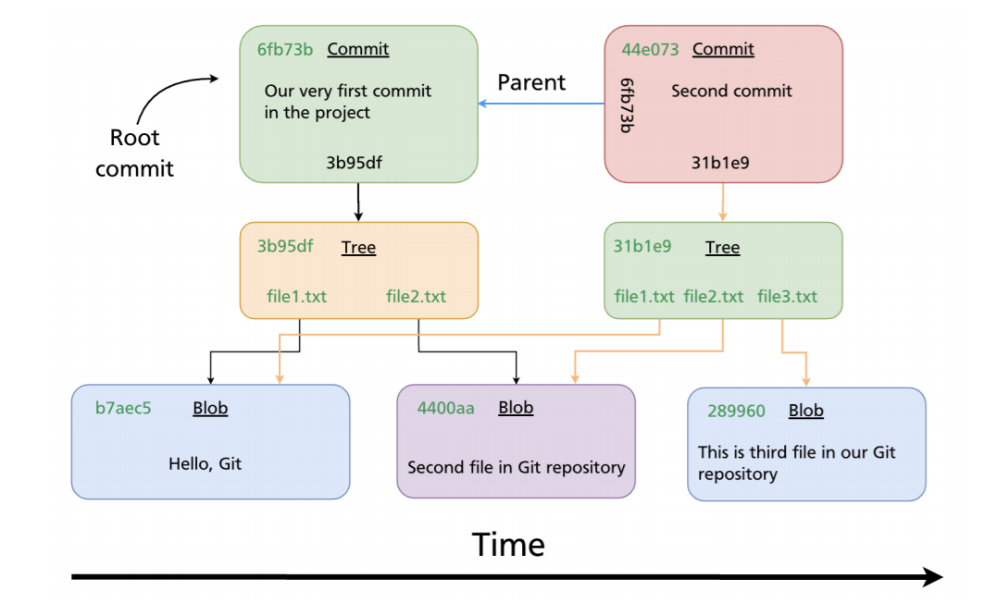

[master (root-commit) f336b84] Very first commit for this project

Commit Overview

When you make a commit, Git stores a commit object that contains a pointer to the snapshot of the content you staged. This object also contains the author’s name and email address, the message that you typed, and pointers to the commit or commits that directly came before this commit (its parent or parents): zero parents for the initial commit, one parent for a normal commit, and multiple parents for a commit that results from a merge of two or more branches.

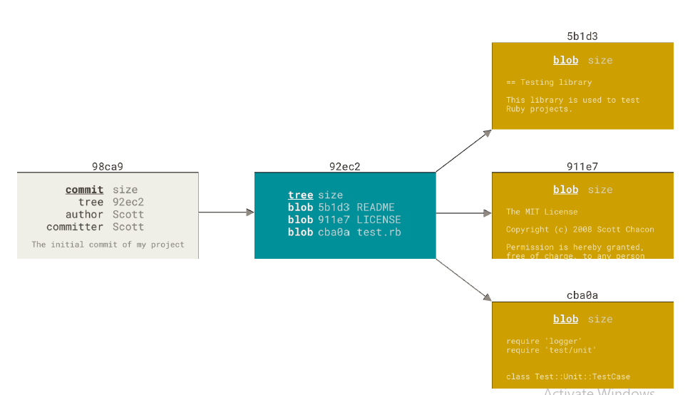

- To visualize this, lets assume that you have a directory containing three files, and you stage them all and commit. Staging the files computes a checksum for each one (the SHA-1 hash we mentioned in Getting Started), stores that version of the file in the Git repository (Git refers to them as blobs),
and adds that checksum to the staging area.

- When you create the commit by running git commit, Git checksums each subdirectory (in this case, just the root project directory) and stores them as a tree object in the Git repository.

- Git then creates a commit object that has the metadata and a pointer to the root project tree so it can re-create that snapshot when needed.

- Your Git repository now contains five objects: three blobs (each representing the contents of one of the three files), one tree that lists the contents of the directory and specifies which file names are stored as which blobs, and one commit with the pointer to that root tree and all the commit metadata.

If you make some changes and commit again, the next commit stores a pointer to the commit that came immediately before it.

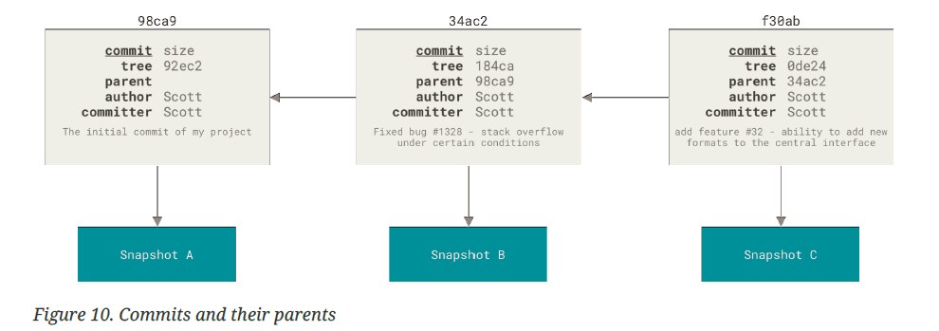

What is Branch ?

- Branching means you diverge from the main line of development and continue to do work without messing with that main line.

- A branch in Git is simply a lightweight movable pointer to one of these commits

- Git branches is incredibly lightweight, making branching operations nearly instantaneous, and switching back and forth between branches generally just as fast.

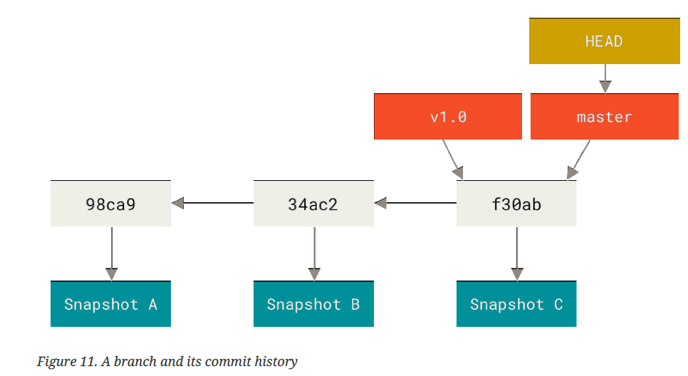

- Default branch is master
- Pointers for all branches are located in .git/refs/heads folder

What is HEAD ?

Branching and Merging

- Let’s go through a simple example of branching and merging with a workflow that you might use in the real world. You’ll follow these steps:
- Do some work on a website.
- Create a branch for a new user story you’re working on.
- Do some work in that branch.

At this stage, you’ll receive a call that another issue is critical and you need a hotfix. You’ll do the following:

- Switch to your production branch.
- Create a branch to add the hotfix.
- After it’s tested, merge the hotfix branch, and push to production.
- Switch back to your original user story and continue working.

If your working directory or staging area has uncommitted changes that conflict with the branch you’re checking out, Git won’t let you switch branches.

It’s best to have a clean working state when you switch branches. There are ways to get around this (namely, stashing and commit amending)

Merging

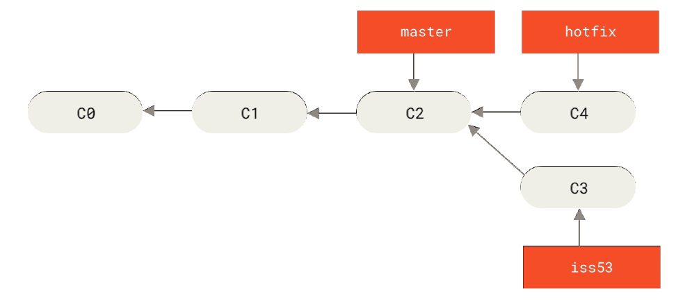

Merging hotfix to master

$ git checkout master
$ git merge hotfix

Fast-forward merging
Because when you try to merge one commit with a commit
- that can be reached by following the first commit’s history, Git simplifies things by moving the pointer forward because there is no divergent work to merge together — this is called a “fastforward.”

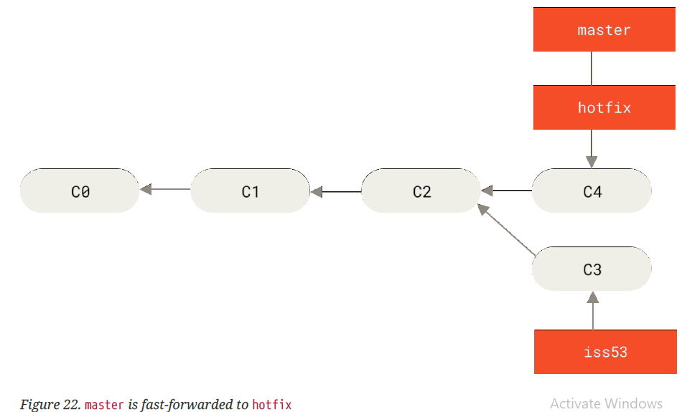

- 3 WAY MERGING

Issue53 into master

your development history has diverged from some older point. Because the commit on the branch you’re on isn’t a direct ancestor of the branch you’re merging in, Git has to do some work.

In this case, Git does a simple three-way merge, using the two snapshots pointed to by the branch tips and the common ancestor of the two.

C2 is the common ancestor

Post 3 way merge

Instead of just moving the branch pointer forward, Git creates a new snapshot that results from this three-way merge and automatically creates a new commit that points to it. This is referred to as a merge commit, and is special in that it has 2 parent . you can delete the iss53 branch so that the pointer iss53 gets deleted but the commit remains intact.

What is Merge Conflicts ?

If you changed the same part of the same file differently in the two branches you’re merging, Git won’t be able to merge them cleanly.

Anything that has merge conflicts and hasn’t been resolved is listed as unmerged

$ git mergetool
$ git mergetool .

Creating New Branch

- $ git branch <List all branches>
- $ git branch <branch name>
- $ git branch testing
- $ git checkout -b <branchname> creates & switch

- What happens when you create a new branch? Well, doing so creates a new pointer for you to move around.

- HEAD points to the current branch
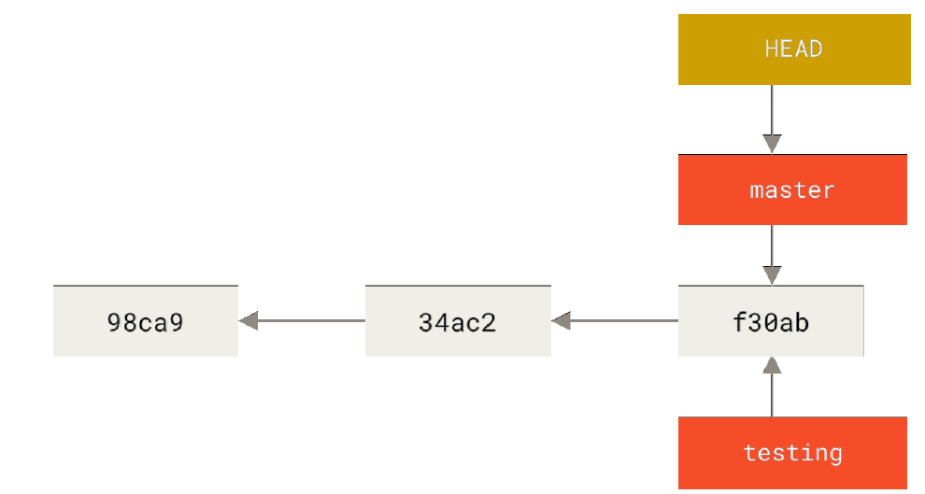

Switching Branches

$ git checkout <branch name>

This moves HEAD to point to the testing branch

If u commit any files here Figure 15. The HEAD branch moves forward when a commit is made.

HEAD moves when you checkout

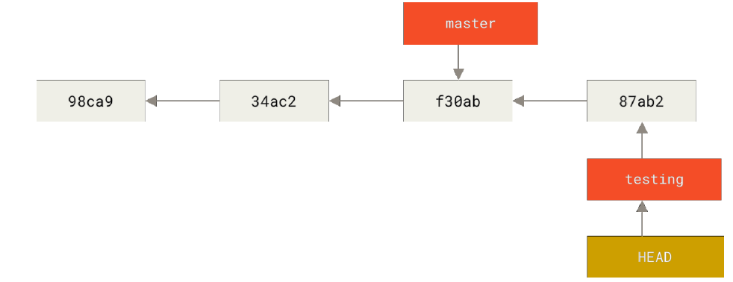
Switching branches changes files in your working directory

It’s important to note that when you switch branches in Git, files in your working
directory will change. If you switch to an older branch, your working directory
will be reverted to look like it did the last time you committed on that branch. If Git cannot do it cleanly, it will not let you switch at all.

Divergent History

$ git log --oneline --decorate --graph –all

This is in sharp contrast to the way most older VCS tools branch, which involves copying all of the project’s files into a second directory. This can take several seconds or even minutes, depending on the size of the project, whereas in Git the process is always instantaneous

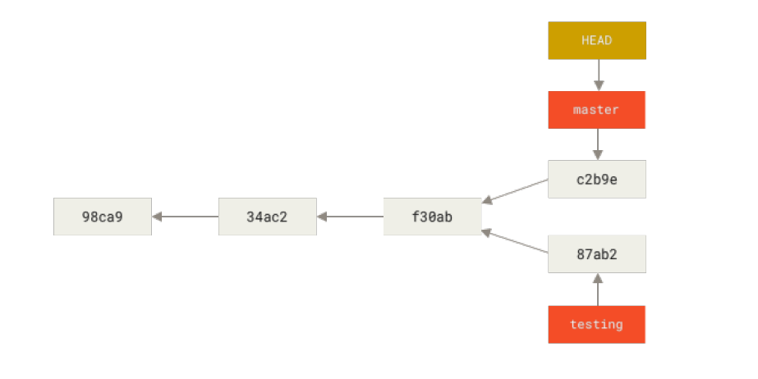

Creating a new branch and switching to it at the same time

- git checkout –b <newbranchname>

Git Branch

- $ git branch [listing of your local branches]
- $ git branch -r [List all remote branches]

- $ git branch –v [To see the last commit on each branch]

- $ git branch -vv

- To see what tracking branches
- If you want totally up to date ahead and behind numbers, you’ll need to fetch from all your remotes right before running this. You could do that like this

- $ git branch –merged

[To see which branches are already merged into the branch you’re on]

[Branches on this list without the * in front of them are generally fine to delete with git branch -d; ]

- $ git branch --no-merged
[To see which branches are not merged into the branch you’re on]

Delete the branch

- $ git branch -d hotfix

- $ git branch -D hotfix [force delete]

Git Remote

Showing Your Remotes

- $ git remote
- $ git remote –v [with url]

Inspecting a Remote

- $ git remote show <remote name>

Adding Remote Repositories

- git clone command implicitly adds the origin remote for you

- $git remote add <remote name> <url>

Renaming and Removing Remote names

- $ git remote rename pb paul
- $ git remote remove paul

- Remote references are references (pointers) in your remote repositories, including branches, tags.

- Once you cloned and merged remote repo iinto your local repo, then remote branch appeared as origin/master where local branch refered as master.

- To synchronize your work with a given remote, you run a git fetch <remote> command (in our case, git fetch origin). This command looks up which server “origin” is (in this case, it’s git.ourcompany.com), fetches any data from it that you don’t yet have, and updates your local database, moving your origin/master pointer to its new, more up-to-date position

Tracking Branches

- Tracking branches are local branches that have a direct relationship to a remote branch. If you’re on a tracking branch and type git pull, Git automatically knows which server to fetch from and which branch to merge in.

- When you clone a repository, it generally automatically creates a master branch that tracks origin/master.

- However, you can set up other tracking branches if you wish — ones that track branches on other remotes, or don’t track the master branch.

$ git branch -u origin/serverfix or
$ git branch –set-upstream-to origin/serverfix or
$ git branch –track origin/serverfix

$ git branch –vv
If you want to see what tracking branches you have set up, you can use the -vv option to git branch.

Git Push

- $ git push By default it push the upstream branch [master]
- $ git push <remote name> <branch name>
- $ git push origin master

- $ git push <remote name> <local branch name>:<remote banch name>
- $ git push origin feature1:feature1
If feature1 not exist in remote then it will create it in remote & then push your changes.

$ git push origin feature1:master
Also can be pushed to already existing branch as well.

Git FETCH

$ git fetch <remote_name>

Fetch all of the branches from the repository. This also downloads all of the required commits and files from the other repository.

$ git fetch <remote_name> <branch>

Same as the above command, but only fetch the specified branch

$git fetch –all
A power move which fetches all registered remotes and their branches

$git fetch –dry-run

$git log –oneline master..origin/master
$git log origin/master

Git Pull

$ git pull <remote_name>
- Fetch the specified remote’s copy of the current branch and immediately merge it into the local copy. This is the same as git fetch ＜remote＞ followed by git merge origin/＜current-branch＞
$ git pull –no-commit <remote>

- Similar to the default invocation, fetches the remote content but does not create a new merge commit.

$ git pull –rebase <remote>

- Same as the previous pull Instead of using git merge to integrate the remote branch with the local one, use git rebase.

- While the git fetch command will fetch all the changes on the server that you don’t have yet, it will not modify your working directory at all. It will simply get the data for you and let you merge it yourself.

- However, there is a command called git pull which is essentially a git fetch immediately followed by a git merge in most cases

Deleting Remote Branches

$ git push origin --delete <remote branch>

- Basically all this does is remove the pointer from the server. The Git server will generally keep the data there for a while until a garbage collection runs, so if it was accidentally deleted, it’s often easy to recover.

Rebasing

Rebase vs merging

- In Git, there are two main ways to integrate changes from one branch into another: the merge and the rebase.

- rebase has powerful history rewriting features

- Rebasing is the process of moving or combining a sequence of commits to a new base commit.
- From a content perspective, rebasing is changing the base of your branch from one commit to another making it appear as if you'd created your branch from a different commit. t's very important to understand that even though the branch looks the same, it's composed of entirely new commits.

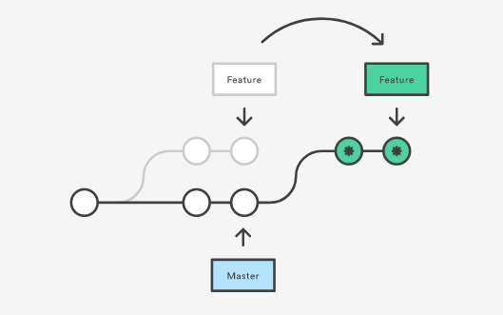

- $ git checkout feature
- $ git rebase master

This moves the entire feature branch to begin on the tip of the master branch, effectively incorporating all of the new commits in master. But, instead of using a merge commit, rebasing re-writes the project history by creating brand new commits for each commit in the original branch.

After Rebase

This operation works by going to the common ancestor of the two branches (the one you’re on and the one you’re rebasing onto), getting the diff introduced by each commit of the branch you’re on, saving those diffs to temporary files, resetting the current branch to the same commit as the branch you are rebasing onto, and finally applying each change in turn.

At this point, you can go back to the master branch and do a fast-forward merge.

- $ git checkout master
- $ git merge experiment

If you examine the log of a rebased branch, it looks like a linear history: it
appears that all the work happened in series, even when it originally happened in parallel.

More Interesting Rebases

You can also have your rebase replay on something other than the rebase target branch.

Suppose you decide that you want to merge your client-side changes into your mainline for a release, but you want to hold off on the server-side changes until it’s tested further. You can take the changes on client that aren’t on server (C8 and C9) and replay them on your master branch by using the --onto option of git rebase:

$ git rebase --onto master server client

This basically says, “Take the client branch, figure out the patches since it diverged from the server branch, and replay these patches in the client branch as if it was based directly off the master branch instead.” It’s a bit complex, but the result is pretty cool.

$ git checkout master
$ git merge client

When Not To Rebase

The golden rule of rebasing is to not rebase public branches. The rebase would replace the old commits with new ones and it would look like that part of your project history abruptly vanished.

In general the way to get the best of both worlds is to rebase local changes you’ve made but haven’t shared yet before you push them in order to clean up your story, but never rebase anything you’ve pushed somewhere.

Usage

The major benefit of rebasing is that you get a much cleaner project history.

Branching Workflows

Figure 26. A linear view of progressive-stability branching

Many Git developers have a workflow that embraces this approach, such as having only code that is entirely stable in their master branch — possibly only code that has been or will be released.

They have another parallel branch named develop or next that they work from or use to test stability — it isn’t necessarily always stable, but whenever it gets to a stable state, it can be merged into master

It’s used to pull in topic branches (short-lived branches, like your earlier iss53 branch) when they’re ready, to make sure they pass all the tests and don’t introduce bugs

